Dear World,
By Raven Fallon-Cyr

My sense of place is a combination of Placelessness and Commodified. The line that best captures placelessness is, “Dear World, I do not know my place in you.” The best line that shows the Commodified perspective of my poem would be, “I want a place where I can taste the oceans salt on the breeze, that there are mountains that I could climb freely.” My environmental ethic is preservation. The line that conveys this is, “I want a place where there are people who are active and fun, who share my values of preserving you.”

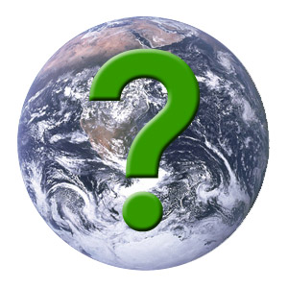

Dear World,

I do not know my place in you.
I have found places that I enjoy
Places that I could be happy in
But nowhere
That I feel like I belong

I want to live in a place
Where I don’t make a mistake
With every step I take

I want to live in a place
Where the town isn’t quite and,
The people aren’t all the same

I crave to live somewhere
Where I don’t have to apologize for being me
I am sick of being in my comfort zone
I want to see new things
I’m getting drowsy in this sleepy town
Do you know what I like to do?
Not hike the same damn trail every weekend
Don’t get me wrong

I love the mountains,
The lakes,
But after a while
They end up looking the same
I love this town
But maybe it’s a sign
That every time I get upset
I impulsively mutter,
“I want to go home.”

I envy the people
Who know where they belong,
Who have their place in the world
It must feel great to be in a place
Not craving to be anywhere else

I’m not saying that there is one magical place
That will meet my every need
I know that it will change as I change too,
But I also know that I am not there right now
It can’t be just anywhere

I’ve got some requirements for you world
I want a place where
I can taste the oceans salt on the breeze
That there are mountains that I could climb freely
I need a city full of activities and life

I want a place where
There are people who are active and fun
Who share my values of preserving you
Who crave culture and adventure

Lastly,
I want a place where I feel at home
So that is my wish
If you know of any places,
Please tell me
I crave a sense of place
Sincerely,
Raven.

